Fig.1: Threshold selection for the test image for the proposed TSTM for malaria parasite segmentation.

Fig.2: Different Masks used in the erosion operation.

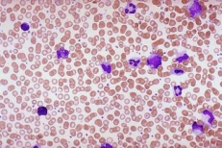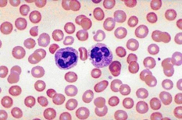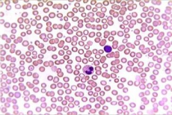
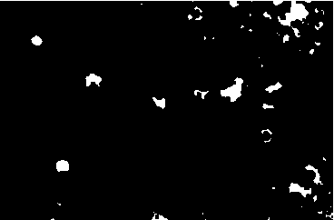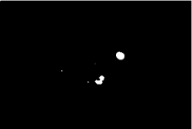
Fig.3: Segmentation of malaria parasite infected cells by proposed method: First row indicates original microscopic malaria infected images and second row represents malaria parasite infected cells extraction.

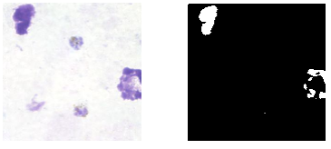
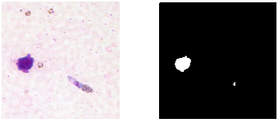
Fig.4: Malaria parasites extraction results in thick blood smear images.

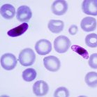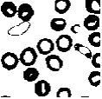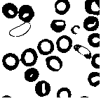
- (b) (c) (d)
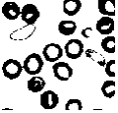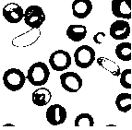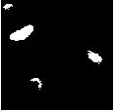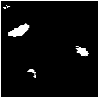
(e) (f) (g) (h)
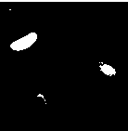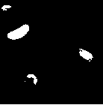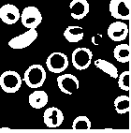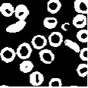
- (j) (k) (l)

Fig. 5: Segmentation results for various values of $α$ for malaria microscopicy image: (a) Original, (b) ground truth image, (c)–(l) proposed thresholding results for different values of $β$ with$β=$ 0.1, 0.2, 0.3, 0.4, 0.5, 0.6, 0.7, 0.8, 0.9, and 1.0, respectively.

