Wool Sector Analysis for Pakistan

Dr. Sabahat Akram
Director Planning and Development in University Management Sciences and IT Kotli Azad Kashmir
E mail: Sabahat_abrar@hotmail.com
Engineer Qurratulain siddiqui
Dr. Iftihar A, Butt
Dean Faculty of Social Sciences and Humanities University Management Sciences and IT Kotli
Azad Kashmir
Dr. Muhammad Shabbir
Assistant Professor
UMSIT Kotli AJ&K

Abstract
There is a great prospective to develop wool sector as industry and economically viable rural avocation in Pakistan. It is a labor intensive and combines both Industry and livestock. It generates quick returns on low investment, is a source of self employment, and generates exports and foreign exchange earnings. Objective and scope of this basic and exploratory research is to the map and value chain of wool sector right from the livestock breeding and handling to value added wool products in Pakistan. This research study will based on both quantitative and qualitative data set as it involves surveying of wool related establishments all over Pakistan, as well as qualitative data and validation of analysis by the stakeholders. This Mapping study will include Objectives, SWOT Analysis, and Market Analysis; SWOT Analysis for wool sector in Pakistan This study will present recommendations for the growth of the sector. It will also be useful in providing an understanding of complete process to the policy makers for poverty reduction and tackling unemployment. And it will serve as database for short term and long term planning and future research.
Key words: Wool, Sheep, Wool Fibers, Silk
- BACKGROUND:
Wool is the most commonly used natural protein fiber in textile industry .The fiber density of wool is 1.31g/cm3 making it a medium weight fiber. The cross section of the wool fiber is usually oval in shape. Generally, wool has four types that is it can course, long & coarse, Medium and fine, Pakistan is mainly producing coarse wool, which is considered average one in the world market and is can be used in handmade carpet production. The whiter (to Pale) the shade of the wool the higher the price it will fetch. higher prices as compared to pale-colored. The product portfolio of wool is very diversified as wool can be used as a part in many textile products as intermediaries, finished textiles, knitwear, blankets, carpets and an emerging presence in technical textiles. Wool industry is a rural based industry but at the same time it can be an important export oriented industry.
Wool is very important for the reason that it can be used separately and as well as it enhances the unique properties of any other fiber e.g. cotton or any other natural and man-made fibers when blended with it. fabrics produced by blending different fibers with wool ,has many added properties unique properties including better styling , cheaper prices and the ability that these can be worn through out the year. Today various fibers are blended with wool include Viscose, Bamboo, Polyester, Acrylic, linen and Spandex.¹ (www.woolboard.nic.in)

In Pakistan Woolen textiles and clothing industry is almost non existent as compared to the cotton and other manmade fiber based textiles and clothing industry. However, the woolen sector can play an important role as its value chain starts with the rural economy and links it with the manufacturing industry having both large and smaller units.

2. SITUATION ANALYSIS (PAKISTAN):
Wool can play an important role in Pakistan’ s fiber mix as it is a necessory part of winter clothing and carpet industry in pakistan. Pakistan is world’s 10th largest sheep rearer and 13th largest wool producer country in the world. The fineness of fiber ranges from 35-45 micronier of Pakistani wool. Wool is the most commonly used natural protein fiber in textile industry .The fiber density of wool is 1.31g/cm3 making it a medium weight fiber. The cross section of the wool fiber is usually oval in shape. The fineness of fiber ranges from 35-45 micronier of Pakistani wool. The staple length of Pakistani wool is ranges between 2cm-6cm.Different breed have different productivity but Average quantity of wool production ranges from0.8-2kg /animal/year which is very less as compared to average of 2.4 kg/animal/year prevalent in rest of world. In Pakistan white and yellow wool fibers comes in winter and summer(August) respectively .the yield of the white wool fiber is about 25-30% and yellow wool fiber is 40-45%.If sand is eliminated at the time of shearing the yield can be improved upto 60-65%.
Unfortunately Pakistan is producing only some courser qualities of wool only which can only be used for the production of carpets and blankets. and finer qualities of wool (for example Merino wool) needed for blended apparel industry have to be imported by the local industry.(pjt) The dependence on imports makes the sector vey much vulnerable in the wake of fluctuating international wool prices and unfavorable exchange rates. The under production of fine grade wool that can be used in apparel woolen industry compels the industry to import it from other countries like Australia and New Zealand.
Like many other developing nations and economies ,Marketing of wool in Pakistan is mainly done by the private wool merchants and traders, and wool supply chain involves various intermediaries (as many as 4-5 intermediaries) before reaching the consumers. Therefore, wool growers have less incentives like getting a better price.

Baluchistan, Bahawalpur, tribal areas and cholistan are the main wool producing region of Pakistan. The wool produced by this region is of carpet grade wool.KPK produces fine quality wool which is used for shawl, handicraft and cottage industry. The amount of wool produced by KPK and AJK is very less as compared to total wool fiber production.
Important sheep breeds are Baluchi, Bibrik, Harnai and Rakhsani in Balochistan Bucchi, Lohi, Thalli and Salt Range in Punjab;; Balkhi,Damani and Kaghani in NWFP and Dumbi, Kachhi and Kooka in Sindh.(bhutto 1993,sciencevision.org)

2.1 Sheep Population
Graph 1. Livestock Sheep Population Of Pakistan 2009-2013

SOURCE: Animal husbandry commission

2.2. Province wise production of wool fiber

Estimated province wise production of wool fiber shows that Baluchistan is leading province in wool production as compared to other province, it produces 44% of total sheep production. Important sheep breeds are Baluchi, Bibrik, Harnai and Rakhsani in Balochistan Bucchi, Lohi, Thalli and Salt Range in Punjab;; Balkhi,Damani and Kaghani in NWFP and Dumbi, Kachhi and Kooka in Sindh.(bhutto 1993,sciencevision.org) Unfortunately due to rural uneducated rearers of sheep the faulty shearing leaves 20 % of the wool lost and about 1/4 wool is left over body of sheep..

Graph II. province wise production of wool fiber

SOURCE: Animal husbandry commission
2.3. Structure of Wool Industry in Pakistan
Pakistan’s woolen industry consist of the following¹ :
- Composite mills
- Combing units
- Woolen and worsted spinning units
- Woven & Knitwear Garments
- carpets manufacturing unit
- Handmade carpets industries

Pakistan has 104 woolen mills as per trade directory of Pakistan woolen mills association 1999 out of which currently only 10-12 are apparel manufacture units are active. Most of the mills have been closed because of low demand, high prices and market saturation of woolen product. There is no any wool mill association registered in DGTO list.(DGTO)

2.4 Pakistan fiber market 2012-13:

Raw Wool production = 43.55 (000 ton’s
Raw cotton production= 2580 (‘000’ M /tons
Manmade fiber production= 610000 (PSF) +56000 (PFY) =666000 tons
Raw silk production = 31000 kg

3. GLOBAL WOOL MARKET ANALYSIS

3.1. Wool producing countries of the world

top wool producing countries in the world are New Zealand Australia, china, and UK. These countries exports more than 60% of wool supplied in the international market. Australia is the largest producer of apparel wool and it provide is two-thirds of the wool in world market . main importers of Australian wool are China, Taiwan, Italy, India, , Czech Republic, France and Germany. (agmrc.org)Besides India, South Africa, Iran, Pakistan, Morocco, Kazakhstan and Syria are other important countries which keep large number of sheep and produce big amounts of wool.

Table 1 Wool trading countries of the world
Products |  | Main importers |  | Main exporters
Wool tops |  | Italy, Germany, China, Turkey, South Korea |  | China, Germany, Uruguay, Czech Republic, Argentina
Wool worsted yarn |  | China, Italy, Germany Hong Kong , Japan |  | China, Hong Kong, Poland, Germany, Italy
woolen yarn |  | Belgium, Honk Kong, USA Australia, Denmark, |  | New Zealand, Hong Kong, Belgium, China, , Lithuania
knotted carpets (Wool) |  | USA, Germany, Czech Republic, UK, Turkey |  | India, Iran, Nepal, Afghanistan, Pakistan
woven carpets (Wool) |  | USA, UK, Germany, Russia, UAE |  | China, India, Belgium,UK, UAE
Wool tufted carpets |  | USA, UK, Australia, Germany, Canada |  | India, Belgium, China, New Zealand, Netherlands
Source:IWTO

3.2. Global trend of Wool fiber Consumption
As many countries are phasing out of labour intensive and longer value chains of wool production, World wool production is on the decline since the past several years On the other hand, production of wool in China, the second largest wool producer, is on an upward trend. (imt)China is a major export destination for USA wool.

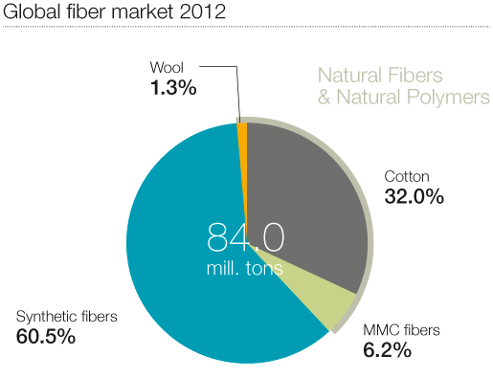 Source: Lenzing estimates

The world fiber market with a volume of about 84.0 million tons is dominated by oil-based synthetic fibers (a share of about 60.5%). Cellulosic fibers which consist of cotton with approx. 32.0% of volume and man made cellulose fibers are (approx. 6.2%), with partially better properties than cotton. The smallest share of the global fiber market had wool with approx. 1.3%.(

Graph III. Evolution of world apparel fiber consumption, in million tons
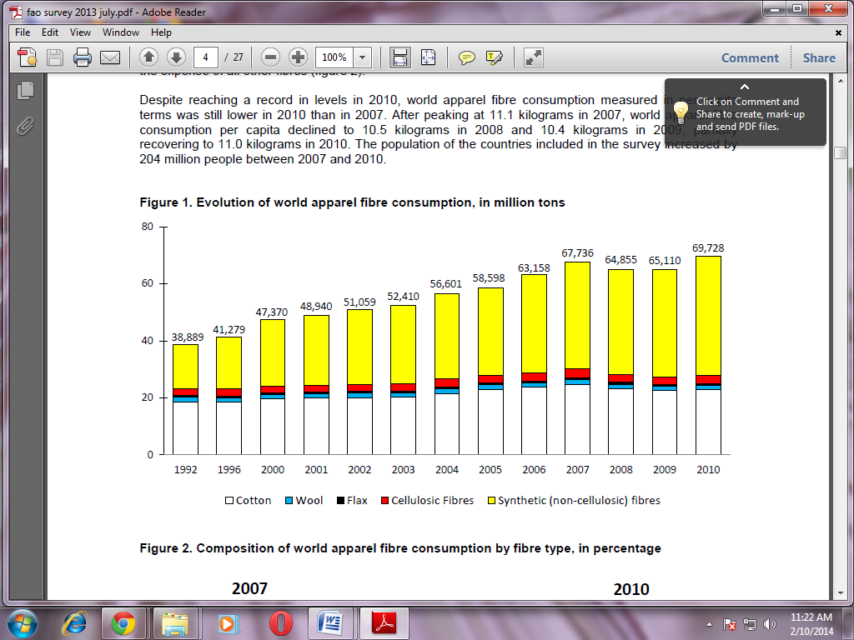

source: FAO UN (world apperal fiber survey 2013)
Wool demand was 280,000 tons lower in 2010. Consumption of cotton, wool, and cellulosic fibers in2010 was lower than in 2007, indicating that the partial recovery observed in 2010. Consumption of wool continued declining in 2009 and 2010, while consumption of cellulosic and synthetic fibers increased in both years

4.MARKET ANALYSIS FOR WOOL SECTOR OF PAKISTAN

4.1. Export and Imports of Pakistan 2008-2012:

- Pakistan export of hand knotted carpets compete with India, Iran, Afghanistan, Nepal Pakistan wool supplies compete with coarser grade wools from New Zealand, China, Uruguay, Argentina, Czech Republic, Germany in raw material . New Zealand is the world’s second-largest wool producer and exporter. Most of its wool production (90%) is exported as fiber. New Zealand is the leading producer of coarse or strong wool used primarily for interior textiles such as carpets, blankets, upholstery and yarn. China accounts for about 25 percent of New Zealand’s wool exports. Other export markets include the United Kingdom, India, Italy and Australia

Source: Ministry of textile
Most of the raw material and yarn is imported for apparel industry and carpet industry due to shortage of high grade wool. This import quantity can be covered if local species of sheep will be replaced by cross breeding so that not only local requirement can be fulfilled but precious foreign exchange be also saved.

Source :Ministry of Textile
As graph shows Carpet has a major share in woolen product export while garments, made-up, yarn and fabric has nearly 0% share. This indicates that a entire supply chain of apparrel grade wool fiber is not completed in the country. There is a need to develop industries which produces value added product of this fiber and its blend.

4.2 Duty regime for wool sector

Heading /  Sub-heading | DESCRIPTION | Custom Duty %
51.01 | Wool, not carded or combed. | 0
51.02 | Fine or coarse animal hair, not carded or combed. | 5
51.03 | Waste of wool or of fine or coarse animal hair, including yarn waste but excluding garnetted stock. | 5
51.05 | Wool and fine or coarse animal hair, carded or combed (including combed wool in fragments). | 0
51.06 | Yarn of carded wool, not put up for retail sale. | 0
51.07 | Yarn of combed wool, not put up for retail sale. | 5
51.08 | Yarn of fine animal hair (carded or combed), not put up for retail sale. | 5
51.09 | Yarn of wool or of fine animal hair, put up for retail sale. | 10
51.11 | Woven fabrics of carded wool or of carded fine animal hair. | 15
51.12 | Woven fabrics of combed wool or of combed fine animal hair. | 15
IMPORT DUTY STRUCTURE……(source FBR)
Heading /  Sub-heading | DESCRIPTION | Custom Duty %
57.01 | Carpets and other textile floor coverings, knotted, whether or not made up. | 25
57.02 | Carpets and other textile floor coverings, woven, not tufted or flocked, whether or not made up, including "Kelem", "Schumacks", "Karamanie" and similar hand- woven rugs. | 25
5702.3210 | - - - Synthetic turf for sports fields | 5
57.03 | Carpets and other textile floor coverings, tufted, whether or not made up. | 15
5703.1000 | - Of wool or fine animal hair | 25
 | - Of nylon or other polyamides: | 25
5703.2010 | - - - Synthetic turf for sports fields | 5
5703.3010 | - - - Synthetic turf for sports fields | 5
5703.9000 | - Of other textile materials | 25
57.04 | Carpets and other textile floor coverings, of felt, not tufted or flocked, whether or not made up. | 10
5704.9000 | - Other | 25
5705.0000 | Other carpets and other textile floor coverings, whether or not made up. | 25

5. SWOT ANALYSIS:
5.1WEAKNESS/ THREATS:

- Deterioration of animal livestock sector of Pakistan and quality of herd structure is lost. Lack of development of high wool yielding sheep breeds result in less quantity of production per year.

- Due to low marketable surplus the farmers of the area sell their wool at lower rate because market/transportation charges are higher beyond the reach of the small farmers.
- there is no classification and grading practices, lack of cleaning and mixing of wool with dirt further deteriorates quality of raw materials .Micron of Pakistani wool is widened, length is shortened and contamination is high thus quality is deteriorating.
- Domestic wool factories use all their financial resources to procure raw materials every year; most of raw materials are export to Indian traders. It is a big challenge for domestic factories to get the raw material at consistent prices. Prices are high because of increase ratio to Indian export.
- Inadequate marketing facilities and infrastructure. Ineffective role of state wool marketing organizations in wool producing Areas. Absence of organized marketing and minimum support price system for ensuring remunerative return
- Machine made carpets are sold through intermediaries for cheaper price which they import by turkey. This is negatively affecting the economic resources of the domestic producers. Domestic industry is not much more cost effective including GST of 17% and loses local market share quickly.
- Baluchistan is the main wool producing region but there is no any woollen industry which makes value added product of the raw material. Lack of R&D work for value addition to wool produced in Baluchistan.
- No special arrangements for shearing were made at all, because due to illiteracy they were unaware of it. Shearing is done by the flock owners themselves with the help of locally made scissors, which are not very effective.

- Lack of awareness, traditional management practices, and lack of education and poor economic conditions of woolgrowers.

- Uneconomical return of the produces to sheep breeders i.e. sale of raw wool, Minimum return earned from sale of wool by wool growers.

- Lack of motivation for adopting modern methods of sheep management, machine shearing of sheep, washing & grading of raw wool etc
.
- Inadequate production and processing facilities of apparel fibers i.e. merino wool and Angora rabbit wool.

- Out dated and inadequate pre-loom & post-loom processing facilities. Inadequate dyeing facilities in wool potential areas.
- Lack of R&D work for value addition to wool produced in Baluchistan.
- Currently wool is sent outside of Baluchistan, which is converted into thread for hand-knotted carpet and sent back to Baluchistan. If we are able to curtail this process and get it done in Baluchistan, this will become an enormous economic opportunity for the women.

- Wool export to India as the massive export is not only creating an acute shortage in the local market but also pushing the carpet industry to the wall because the prices of wool have doubled in a short span of time.

- The domestic carpet industry faces stiff price competition from other exporting countries, particularly from Turkey, India and Nepal, in the case of hand-made woolen carpets.
- Non exploration of new market
5.2 STRENGTH/OPPERTUNITIES
- Plenty of raw materials for carpet manufacturing is available in the country.
- Wool products have /GSP+ preferential terms in the EU.
- Pakistan equipments and technology to produce woollen hand knotted carpets products reached world standard.
- Pakistan wool industry still has a large potential for successful development, if we have lower production costs, vicinity to the raw material and to potential outlets of manufactured products.
- Consumer preference for hand tufted carpets in the US and other western markets is growing up. Cheap wool demand is also constantly growing and is mixed with indigenous wool to make hand tufted carpet. So this is an opportunity for Pakistan to gain market share.

6.WAY FORWARD
- Establishment of the Central Wool Development Board defining the role of the CWDB to make it more effective and to enable it to perform the tasks assigned to it appropriately; to be done in close collaboration with wool producers and the user industry. Provide allocation of funds to the Board to enable it to achieve its laid objectives in an effective manner.
- Integrated wool improvement and development program should be started under the domain of CWDB.
- Establishment wool testing authority with proper certification to meet the international wool testing organizations standards. National wool grading system should be revised as per international standards.
- Observing the proceeding of AUS-CHINA joint working group on wool, Pakistan can engage industry through federation of Australia wool organization, facilitating a MOU to enhance consultation on wool and woolen products between Australia and Pakistan and to monitor potential market access issues.
- Farmers in Pakistan use traditional methods of shearing. This is a very slow method of shearing. The wool comes off in very uneven lengths there is a need to develop groups in the different communities for training in shearing and using the shearing machine system, especially the shearing steps. Develop links link the wool activists with the Baluchistan, Karachi and Multan Markets.
- To involve the females in wool trainings and develop a collection point for wool processing. Trainings on simple techniques to convert wool into high value products such as scarf and small rugs using loom
- Train community on classifying wool fiber, Sorting, using of three types of baling machines – manual, hydraulic, and electrical. And about the concept of washing, grading, sorting and baling to gain better wool quality and profit margin
- To improve the quality and quantity of wool in Baluchistan, firstly streamline the wool collection system. Sorting of wool is essential and collection of wool at the producers level. Improve wool-shearing technology which is low cost and economically feasible.
- To create awareness wool education programme should be started at major textile teaching institution like NTU , NED ,TIP, SFDAC and Baluchistan institutes. Links have to be developed within Pakistan wool textile industry and universities to work closely with mills and address mill problem.
- Marketing system need to be able to transmit the premium and discount for various grade of wool so that growers can organize their production to meet better market deman
7.REFERENCES:
Ministry of national foods livestock wing (Animal husbandry commission)
D.G. live stock balochistan (Dr.Ali Buksh somoro)
CEO Sohail Umer from( Moon light industries Hub Karachi)
CEO Miss Shaiza saeed (united carpets)
Balochistan livestock and dairy development department
CEO Mr junaid nawab Sanaullah ( blanket manufacturer)
Mr zahid from oxford knitting.
Mr Munir Ahmad (Saif wool company)
Mr Zahid(regional coordinator from Ahan)
G.M . Mr syed Rizwan Tahir(Lahore carpet manufacturer)
Cholistan cooperative wool develop and marketing union ltd
Mr jarar Afzal (Bannu woolen mills)
Madina wool traders
G.M. Mr Aqdas shah (Ghazi Abbas Woolen mills)
Mr Malik Imtiaz (supplier of raw wool from cholistan)
http://www.fao.org.pk/projects/bap/Outcomes_04.02.pdf
https://www.icac.org/cotton_info/publications/statistics/world-apparel-survey/FAO-ICAC-Survey-2013-Update-and-2011-Text.pdf
http://www.iwto.org
source of import export data: UN comtrade
http://ageconsearch.umn.edu/bitstream/47193/2/IAS04.PDF
http://texmin.nic.in/sector/Note_Woollen_Sector_wwt_skbabbar.pdf

SUBJECT: WOOL SECTOR ANALYSIS
13. with Reference to above mentioned subject and as instructed by the Secretary Mintex, it is to inform you that a preliminary wool sector Report has been developed by EDPIU Mintex. This Report include situation analysis, global market analysis ,SWOT analysis and way forward for wool sector of Pakistan.
16 . The same is placed here (as annexure-I) for kind perusal and further proceedings, please.

Engineer Qurratulain
AD (Sector Analyst)

Director (EDPIU)

